6373793

TDD using JUnit5 and Mockito

1. Junit Basic Testing Exercises

Exercise 1: Setting Up Junit

Scenario:

You need to set up JUnit in your Java project to start writing unit tests.

Code:

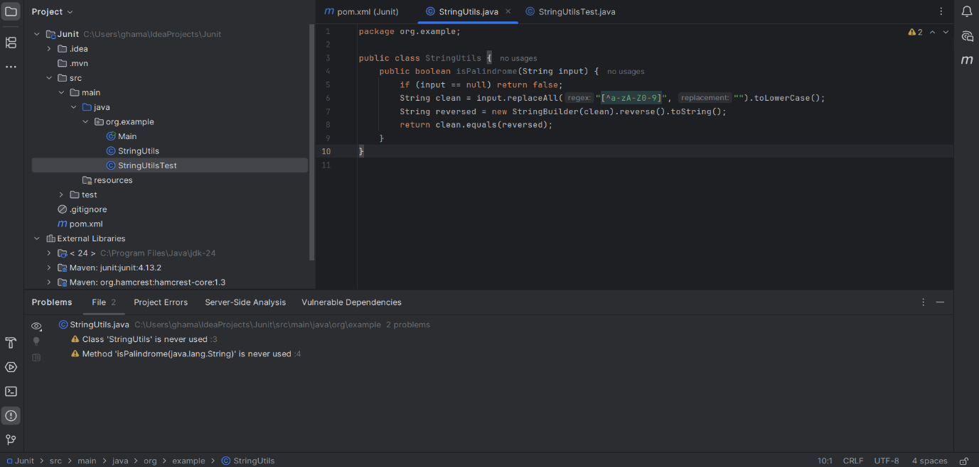

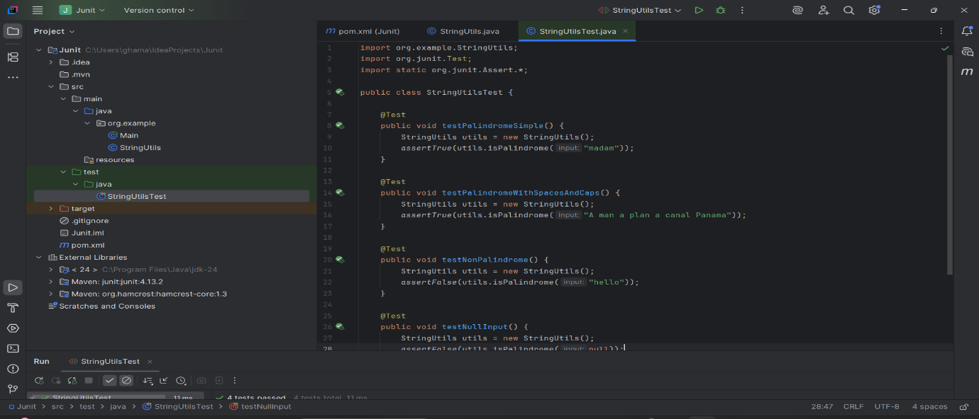

Output:

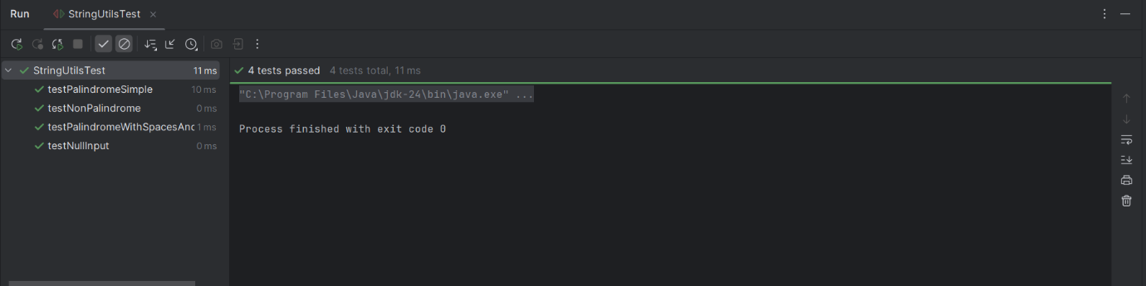

Exercise 3: Assertions in JUnit

Scenario:

You need to use different assertions in JUnit to validate your test results.

Code:

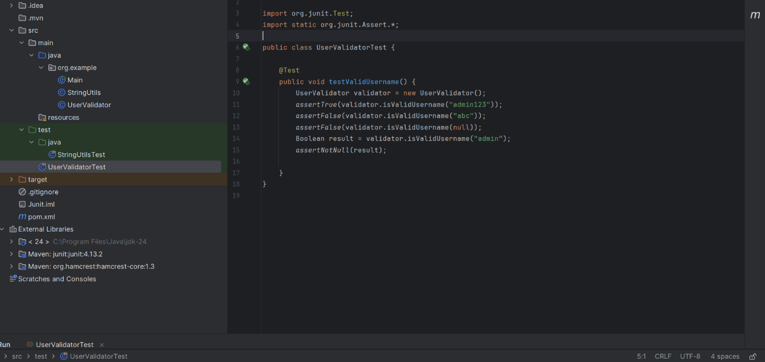

Output:

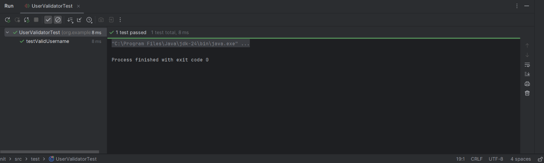

Exercise 4: Arrange-Act-Assert (AAA) Pattern, Test Fixtures, Setup and

Teardown Methods in JUnit

Scenario:

You need to organize your tests using the Arrange-Act-Assert (AAA) pattern and use setup and teardown methods.

Code:

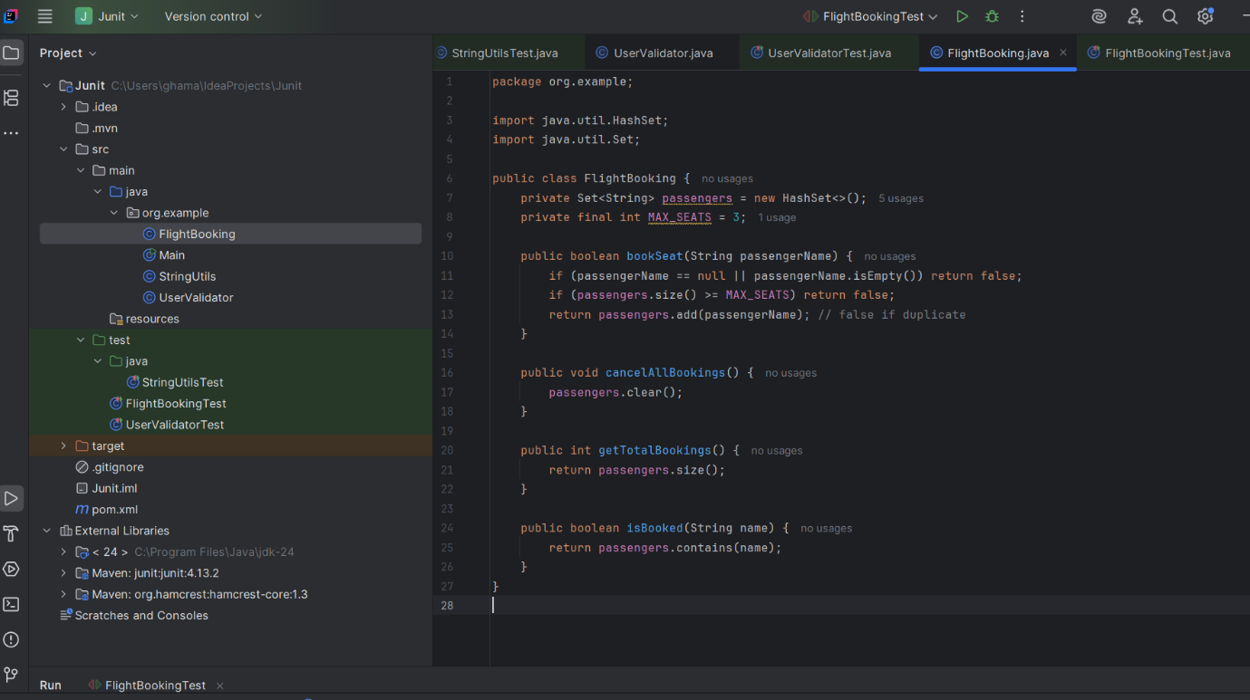

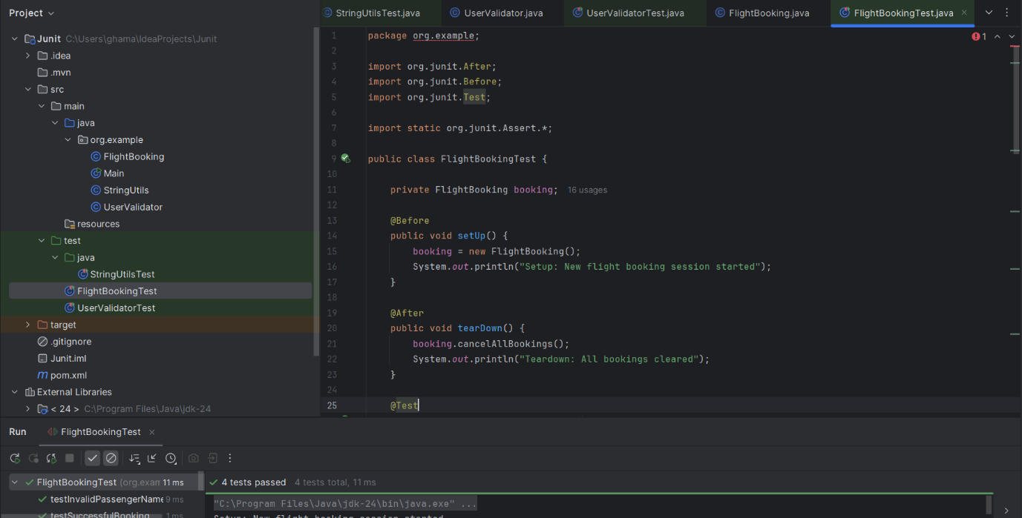

Output:

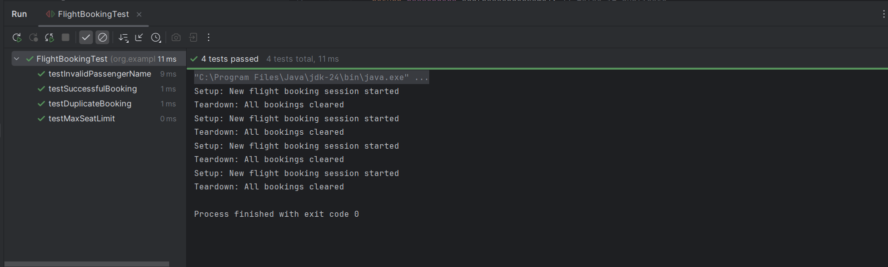

Exercise 1: Mocking and Stubbing

Scenario:

You need to test a service that depends on an external API. Use Mockito to mock the external API and stub its methods.

Code:

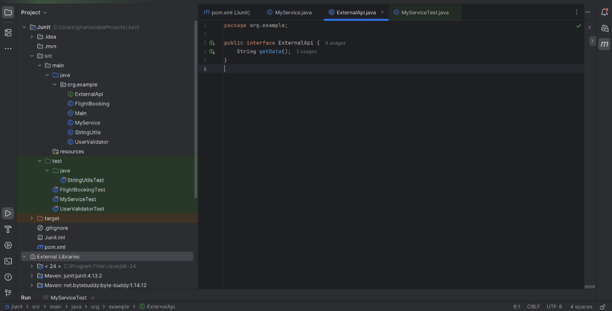

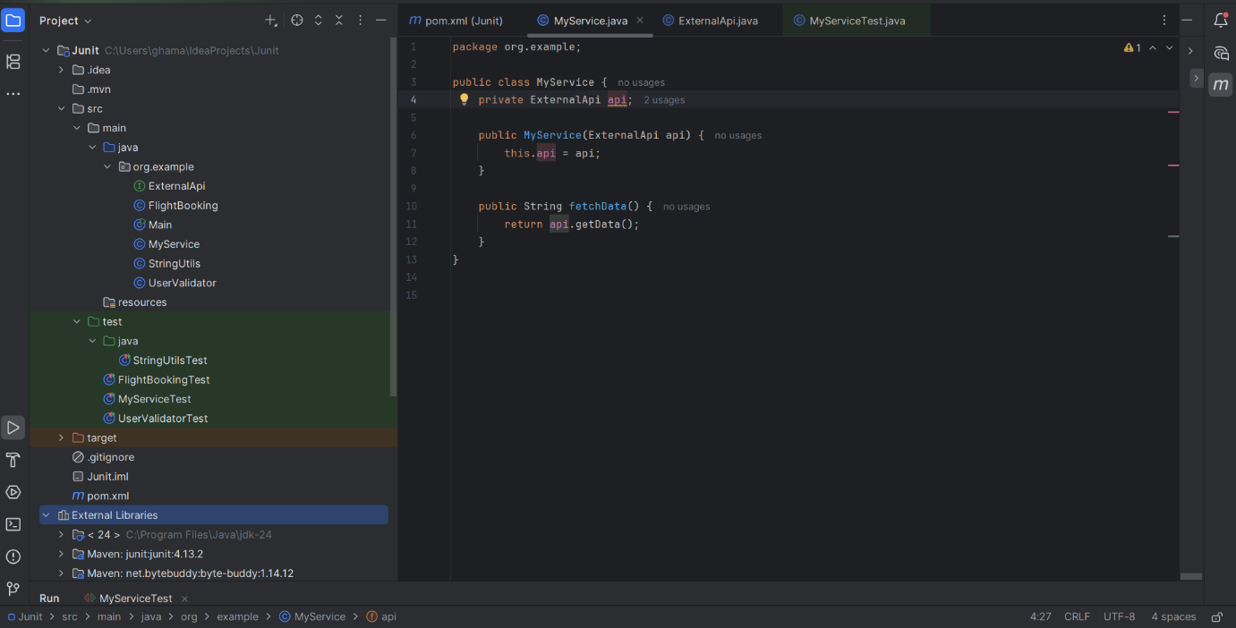

Exercise 2: Verifying Interactions

Scenario:

You need to ensure that a method is called with specific arguments.

Code:

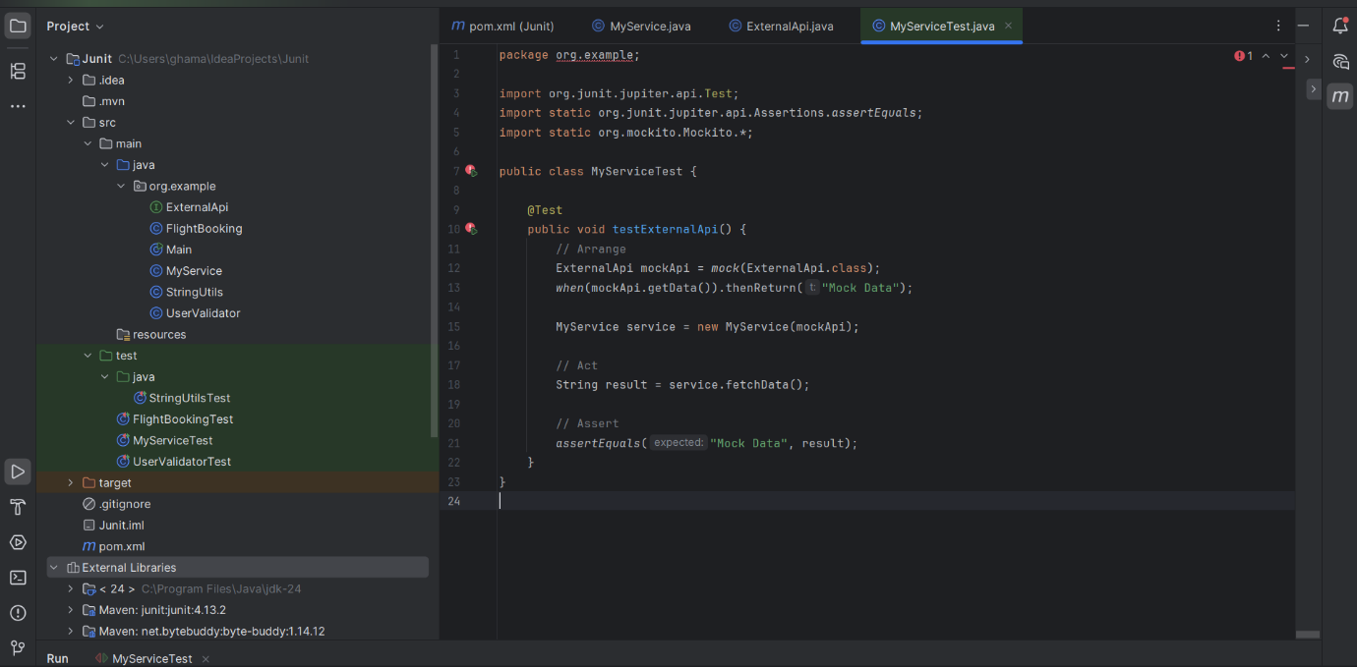

Output:

